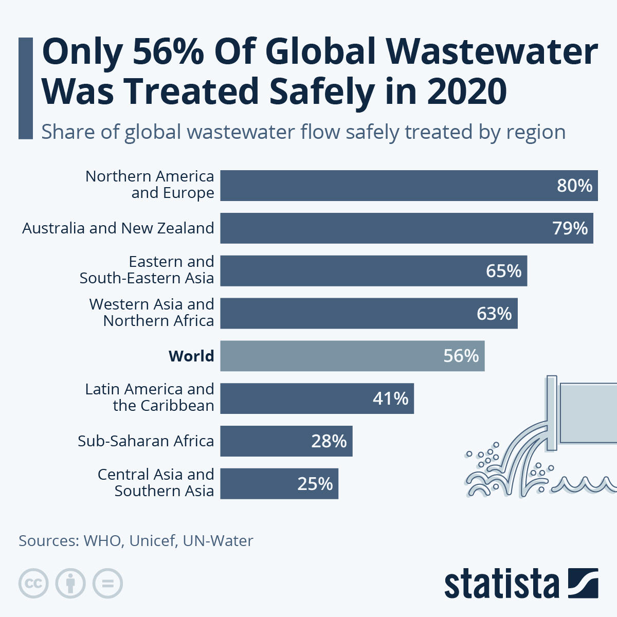
Question 1. What is the primary objective of a sewage treatment plant?
Introduction
Water is very important for people to live. We need water to drink. We also need water to grow food. Cities and factories need water too.
When we use water it gets dirty. This dirty water has stuff in it like waste, chemicals and germs. If we put this water into rivers or oceans it can hurt people and the environment.
To fix this problem we use places called sewage treatment plants. A sewage treatment plant is like a cleaner for water. It makes the water safe to use again. The main job of these plants is to remove the stuff from dirty water. Sewage treatment plants clean the water.
Sewage treatment plants are very important for keeping our environment clean. They help keep our water clean. They stop people from getting sick. If we did not have sewage treatment plants cities would be very polluted. People would get very sick.
Sewage treatment plants play a role, in keeping us and the environment safe. They help protect our water. They keep us healthy. We need sewage treatment plants. They keep our water clean and our environment safe.

Figure 1: Global wastewater statistics showing that nearly 80% of wastewater worldwide is discharged into the environment without adequate treatment.
Definition of Sewage Treatment Plant
A sewage treatment plant is a place that helps clean wastewater from homes, industries and businesses. This wastewater comes from toilets, kitchens, bathrooms, factories and drains. It flows through pipes. Reaches the treatment plant.
Inside the plant workers use methods to remove pollutants. They separate waste get rid of bad germs and remove toxic stuff.
After cleaning the water becomes much safer. They can then release it into rivers or lakes. In some cases they reuse it for watering plants cooling machines or helping groundwater.
Sewage treatment plants are really important, for cities and the environment. They help keep our water clean. They are a part of modern city infrastructure and environmental protection systems.
Types of Wastewater Treated in Sewage Treatment Plants
Sewage treatment plants take care of kinds of wastewater that people make. It is really important to know where this wastewater comes from because different kinds of wastewater can have bad things in them and need to be cleaned up properly.
- Domestic Wastewater:
The wastewater from our homes and apartment buildings is called wastewater. It is the water from our toilets, kitchens, bathrooms, washing machines and sinks. This kind of wastewater mostly has waste, food bits, soap and dirt in it.
- Industrial Wastewater:
Factories and plants that make things produce wastewater. This wastewater can have things like chemicals, heavy metals and oils in it. Because of these things industrial wastewater often needs special cleaning before it can go into the main sewage system.
- Storm-water Runoff:
When it rains, the rainwater that flows over streets, roofs and other things is called storm-water runoff. As it moves it picks up things like dirt, oil and trash. In cities storm-water runoff mixes with sewage and goes into treatment plants.
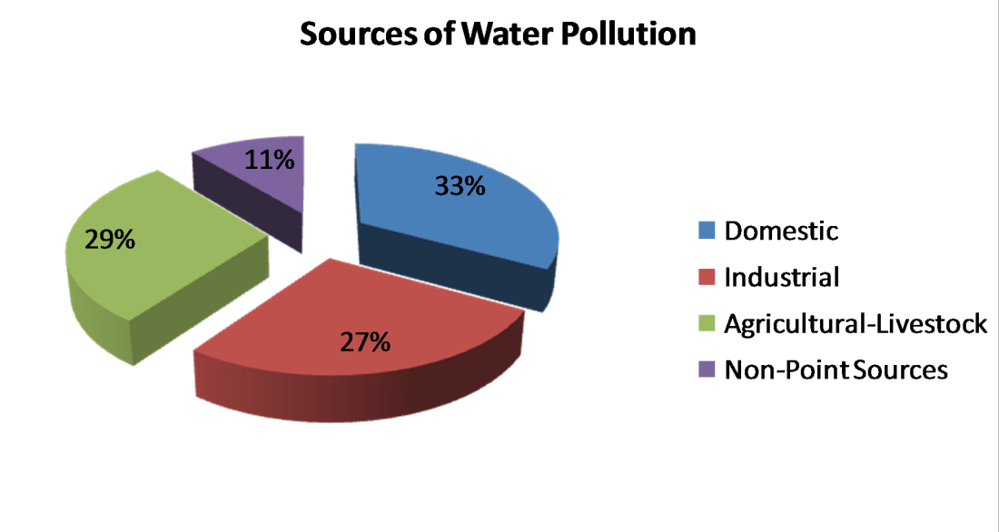
- Agricultural Wastewater
Farms also make wastewater that has fertilizers, pesticides and animal waste in it. These bad things can hurt our water if they are not cleaned up properly. By cleaning up these kinds of wastewater sewage treatment plants help keep our air and water clean and safe for everyone. Sewage treatment plants are very important for keeping our environment safe and clean. They help to treat Domestic Wastewater, Industrial Wastewater, Storm-water Runoff and Agricultural Wastewater which is really important, for our health and the health of our planet.
Figure 2: Major sources of wastewater entering sewage treatment systems. Domestic wastewater forms the largest portion in most urban areas.
Primary Objective of a Sewage Treatment
The main goal of a sewage treatment plant is to clean wastewater to get rid of pollutants and bad stuff before letting it out into nature. This helps keep people healthy keeps the environment balanced and stops water from getting polluted.
Wastewater has lots of things in it like dirt, yucky stuff, germs, extra nutrients and chemicals. If we don't take these out they can hurt animals and plants. Make people and animals sick. A sewage treatment plant tries to get rid of these things in several steps.
This way the water that goes out meets safety standards, for the environment.
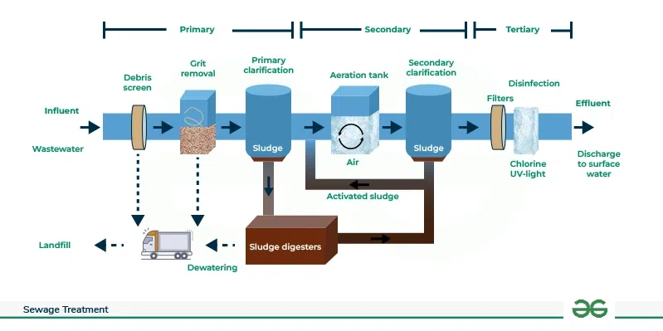
Sewage treatment plant works to reduce these harmful components through several treatment stages. By doing so, the plant ensures that the final discharged water meets environmental safety standards.
Figure 3: Basic stages of a sewage treatment plant showing preliminary, primary, secondary, and tertiary treatment processes.
Removal of Solid Waste and Suspended Particles
A sewage treatment plant has a job to do. It needs to get rid of things and tiny particles that are floating around in the wastewater. Wastewater is full of waste like food bits, paper, plastic things, sand and other junk.
If we do not get rid of these things they can block the pipes hurt the equipment and make the water dirty. The treatment plant uses screens, filters and big tanks to separate the waste from the water during the treatment process. By getting rid of the things that are floating around the sewage treatment plant makes the wastewater much cleaner and gets it ready, for more treatment.
Reduction of Harmful Microorganisms
Sewage treatment is really important for reducing the things that can make us sick like bacteria and viruses and parasites. The water that comes from our homes and hospitals often has these things in it that can cause big problems like cholera and typhoid and dysentery and hepatitis. If we do not treat the sewage and it gets into the rivers or lakes these bad things can spread through the water. Make a lot of people sick.
Sewage treatment plants use ways to make the water cleaner like using living things to break down the bad stuff and using special methods to kill the bad things. They use things like chlorine and special lights and ozone to make the water safe.
Sewage treatment is very important for keeping our communities safe from getting sick from water. Sewage treatment plays a role in protecting us from these waterborne diseases, like cholera and typhoid and dysentery and hepatitis.
Removal of Organic and Chemical Pollutants
Wastewater has a lot of matter and chemical pollutants in it. The organic matter mostly comes from food waste, human waste and things from farms. When these things get into the water they break down and use up the oxygen that is dissolved in the water.
When the oxygen in the water gets low things that live in the water like fish and plants cannot live. This is called oxygen depletion or water pollution.
Wastewater treatment plants use a method that involves living things like organisms to break down the organic waste into simpler things that are not so bad, for the environment. They also use methods to get rid of the bad chemicals and heavy metals that come from factories and industrial wastewater. By getting rid of these things wastewater treatment plants help keep the water and the things that live in it healthy.
Environmental Protection
Sewage treatment plants are very important for keeping our ecosystems safe. Rivers and lakes and oceans are home to a lot of plants and animals. If we put wastewater into these water bodies it can hurt the ecosystems that live there.
When there is a lot of nitrogen and phosphorus in the water it can make much algae grow. This is called eutrophication. It is like when we have a growth of algae in the water and it uses up all the oxygen. This can kill fish and other things that live in the water.
Sewage treatment plants help to remove nitrogen and phosphorus and other bad things from the water. They also help to keep the ecosystems healthy. This helps to keep all the kinds of plants and animals in the rivers and lakes and oceans.
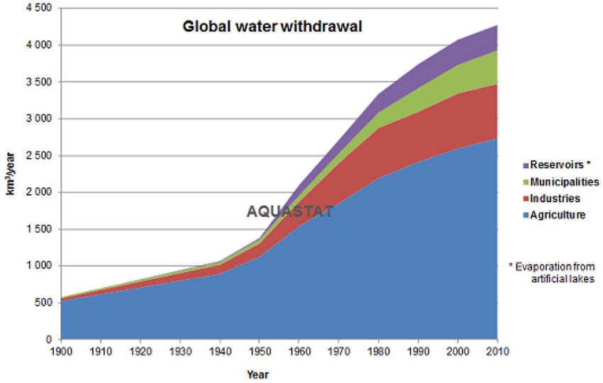
Sewage treatment plants are really good, at helping to maintain the balance of nature. Sewage treatment plants protect all the species that live in the water. By removing these things from the water sewage treatment plants help keep the ecosystems balanced. Sewage treatment plants protect the plants and animals that live in the rivers and lakes and oceans.
Figure 4: Global water use has increased significantly over the last century due to population growth and industrial development.
Protection of Public Health
Sewage treatment plants do an important job. They help keep people healthy. If sewage is not treated it can have things like bacteria and viruses that make people very sick.
In some countries that are not as developed they do not handle wastewater very well. This has caused a lot of people to get sick from water and it has also caused big sanitation problems.
Sewage treatment plants help by making sure the water is clean before it goes back into the environment. This helps keep the water that people drink and the areas where food is grown clean. Sewage treatment plants make sure the water is clean and safe. This makes the whole city a cleaner and healthier place to live. So sewage treatment plants are very important, for keeping people healthy and happy.
Water Reuse and Resource Recovery
Another goal of sewage treatment plants is to help reuse water and recover resources. Many countries are looking for ways to reuse wastewater because the population is growing and there is water available. Wastewater can be used for things like watering plants cooling buildings and other uses where you don't need to drink the water if it is treated first.
This helps because it means we do not need to use much fresh water and that helps save our natural water resources. Some modern treatment plants can even take sewage sludge. Turn it into helpful things like biogas, fertilizers and energy. This makes sewage treatment plants do more, than control pollution. They also help manage resources in a sustainable way.
Conclusion
In conclusion, the main goal of a sewage treatment plant is to clean wastewater and get rid of stuff before it goes into the environment. Sewage treatment plants are really important because they help reduce water pollution and keep people healthy and the environment in balance.
Sewage treatment plants use steps to clean wastewater. They take out waste and bad tiny living things and organic matter and toxic chemicals from the water. This makes sure the water is safe for the environment and does not hurt the world.
Sewage treatment plants also help us reuse water and take care of resources in a way. As more people move to cities and industries grow sewage treatment plants will become more important, for protecting the environment and making sure we have a healthy future. Sewage treatment plants are very important for our society and the environment and sewage treatment plants will help us have water and air.
References:
- Metcalf & Eddy. (2014). Wastewater Engineering: Treatment and Resource Recovery (5th ed.). McGraw-Hill Education.
- Tchobanoglous, G., Burton, F. L., & Stensel, H. D. (2003). Wastewater Engineering: Treatment and Reuse. McGraw-Hill.
- United Nations World Water Assessment Programme (UN-WWAP). (2021). The United Nations World Water Development Report 2021: Valuing Water. UNESCO.
- United Nations Environment Programme (UNEP). (2017). Wastewater: The Untapped Resource. United Nations.
- World Health Organization (WHO). (2018). Guidelines on Sanitation and Health. World Health Organization.
- Food and Agriculture Organization (FAO). (2020). AQUASTAT Database – Global Water Use Statistics. FAO.
- Environmental Protection Agency (EPA). (2023). Wastewater Treatment Process Overview. (https://www.epa.gov)
- Water Environment Federation (WEF). (2018). Wastewater Treatment Fundamentals. WEF Press.
- Figure 1: https://www.statista.com/chart/29547/domestic-wastewater-flow-safely-treated-by-region/?srsltid=AfmBOoptQb7yIXXAZ-77f_67EMNIf5AcTQbc3fmA7Pc9hKL9iKsUZUA_
- Figure 2: https://wepa-db.net/wp-content/themes/wepa/pdf/the-12th-annual-meeting-10.pdf
- Figure 3: https://www.geeksforgeeks.org/biology/sewage-treatment-process/
- Figure 4: https://www.researchgate.net/figure/Global-water-withdrawal-over-time-by-FAO_fig1_356173638

Question 2. Describe the four main stages of sewage treatment.

Introduction
Sewage treatment is an important thing. It helps to make wastewater clean before we put it back into the earth. Wastewater comes from homes, factories, shops, hospitals and storm water systems. This wastewater has a lot of stuff in it like dirt and waste and germs and chemicals and extra nutrients. If we do not treat sewage and just put it into rivers or lakes or oceans it can make the environment very dirty. It can make the water bad. Hurt animals that live in the water and spread diseases to people. So we need to treat sewage to keep people healthy and help the environment.
Sewage treatment plants are built to remove the stuff from wastewater. They do this in a steps. These steps are organized into parts so that the bad things can be removed slowly and properly. Each part of the treatment targets kinds of bad things and uses different ways like using filters breaking down with tiny living things and using chemicals. The sewage treatment process has four parts: preliminary treatment, primary treatment, secondary treatment and tertiary treatment. These parts of sewage treatment work together to make wastewater much cleaner before it goes back into nature.
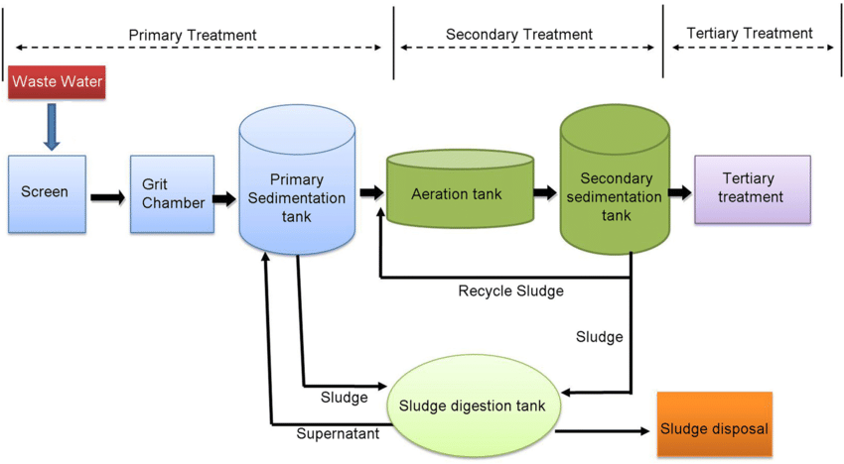
Sewage treatment plants use these steps to remove the things from wastewater. Wastewater gets cleaner and safer with each stage of sewage treatment. The goal of sewage treatment is to protect our health and the environment. These stages of sewage treatment work to greatly increase the quality of wastewater before it is released back, into the environment.
Figure 1: Flow diagram of a typical sewage treatment process showing preliminary, primary, secondary, and tertiary treatment stages.
Preliminary Treatment
The first step in treating sewage is called preliminary treatment. The main goal of this step is to get rid of heavy things from the wastewater that comes in. These things are usually called debris and grit.
Wastewater from cities and industrial areas often has things like plastic bags, pieces of cloth, paper, sticks, bottles, food packaging and other solid waste. If these things get into the treatment system they can block pipes hurt the pumps and cause problems with the rest of the treatment process.
To stop these problems from happening sewage treatment plants use equipment to screen the water at the beginning. They put up metal screens to catch the big things in the wastewater. These screens let the water go through. They keep the solid waste out.
After the screening the wastewater goes into grit chambers. In these chambers the water flows slowly so that heavy things like sand, gravel, broken glass and small rocks can sink to the bottom. Then these things are taken out. Thrown away properly.
The first step in treating sewage may also involve getting rid of oils and grease that float on the surface of the water. Sometimes special devices called skimmers are used to take out these floating things. Even though the first step does not get rid of the things that are dissolved in the water it is very important for keeping the equipment safe and getting the wastewater ready, for more treatment. By taking out the heavy things at the start the whole sewage treatment system works better.
Primary Treatment
The primary treatment of sewage is the second step. It is the stage of treating wastewater. The main goal of treatment is to get rid of the solid bits and some of the bad stuff that is in the water. When wastewater goes through treatment it flows into big tanks. These tanks are called sedimentation tanks or primary clarifiers. The water moves slowly in these tanks. It has to sit there for a while.
Because things that are heavy sink to the bottom the solid bits in the water settle at the bottom of the tank. This stuff that settles is called sludge. Primary sludge is mostly made up of waste like food bits and other solid things that were not removed earlier.
At the time things that are light, like oils and fats float to the top of the water. These things form a layer on the water called scum. We use machines to remove this scum from the water.
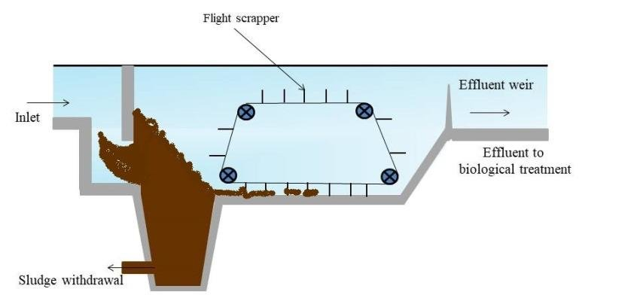
Primary treatment of wastewater really helps to reduce the amount of bits in the water. On average it can get rid of 50 to 60 percent of these solid bits and about 30 to 40 percent of the bad organic stuff. Even after primary treatment the water still has some bad stuff, in it. It has living things and dissolved organic substances. So we need to treat it some to get rid of these things. Then the water moves on to the step, which is called secondary treatment of the wastewater.
Figure 2: Primary sedimentation tank where suspended solids settle at the bottom forming sludge while lighter materials float as scum.
Secondary Treatment
Secondary treatment is an important part of making wastewater clean. This stage helps get rid of the stuff that is dissolved and can be broken down by living things, which is still in the water after the first cleaning stage. It is different from the two stages, which mainly use physical methods to clean the water.
Living things like bacteria and protozoa is used in secondary treatment to eat the bad things in the water. These tiny living things eat the stuff and turn it into simple things like air, water and tiny bits of living things. This helps make the water much cleaner.
One popular method used in treatment is called the activated sludge process. In this process wastewater is mixed with air and tiny living things in tanks. Air is added to help the tiny living things grow and eat the stuff. The tiny living things make clumps called flocs as they eat the bad stuff. Then the mixture of wastewater and tiny living things goes into another tank where the clumps settle at the bottom and form activated sludge. Some of this sludge is sent back to the tanks to keep the tiny living things alive and the rest is taken out for further processing.
Another method used is the trickling filter system. In this system wastewater flows over rocks or plastic. Tiny living things grow on these materials.
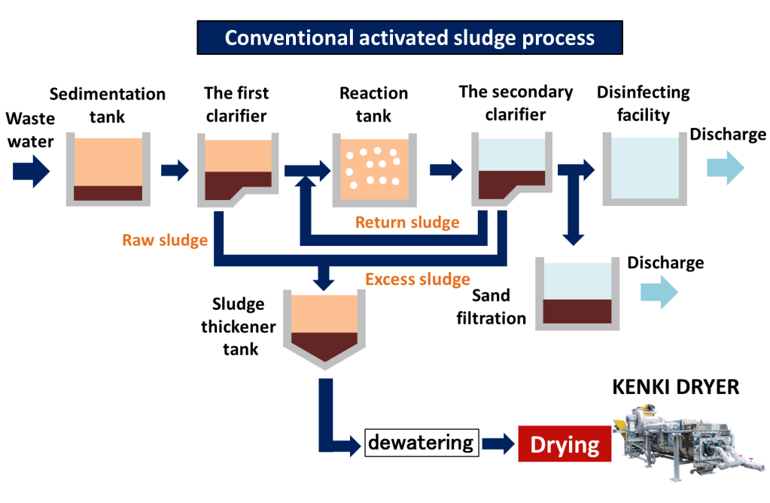
Secondary treatment works well to reduce the bad stuff in wastewater. It can remove about 85 to 90 percent of the stuff, in the water. After this stage the water is much cleaner. There might still have some tiny things and nutrients in it.
Figure 3: Activated sludge process used in secondary treatment where microorganisms break down organic pollutants in wastewater.
Tertiary Treatment
Tertiary treatment is the step of sewage treatment and it is also called advanced treatment. The main goal of treatment is to get rid of any pollutants that were not removed in earlier stages. This stage is about making the treated wastewater very clean so it meets environmental standards for release or reuse.
One of the processes used in tertiary treatment is filtration. Sand filters, membrane filters or other filtration systems are used to remove small particles that are still in the water. Filtration helps make the water cleaner.
Another important step is disinfection. After completing secondary treatment, there still might be some bad microorganisms in the water. Treatment plants use disinfectants like chlorine, ultraviolet light or ozone to kill these harmful microorganisms.
Tertiary treatment also helps remove nutrients like nitrogen and phosphorus. These nutrients can cause problems if they get into natural water bodies in amounts. When this happens, it can contribute in growth of algae and aquatic plants. This can seriously reduce oxygen levels in the water and hurts aquatic life.
Many advanced technologies like activated carbon filtration, reverse osmosis and advanced oxidation processes are used by advanced sewage treatment plants. These technologies help remove small substances that causes pollution, and after removal of these substances the quality of water increases. Tertiary treatment makes the water very clean and safe. In countries this treated water is used again for irrigation, landscaping, industrial cooling and groundwater recharge.
Tertiary treatment is really important for making wastewater clean and safe. It helps protect the environment and public health. The treated water, from treatment is reused in many ways. It helps conserve water and reduce waste. Tertiary treatment is a part of sewage treatment.
Thus tertiary treatment is one of the best methods to get clean and safe water. By removing harmful substances like nitrogen and phosphorus, it makes the water much suitable for agriculture, industrial use.
Importance of Multi-Stage Sewage Treatment
The thing about sewage treatment is that it needs to happen in stages. This is because wastewater has a lot of kinds of bad stuff in it. Each stage of sewage treatment is meant to get rid of pollutants.
Preliminary treatment is when they take out pieces of junk and heavy stuff that sinks to the bottom. Then there is primary treatment which gets rid of the tiny particles that float around. After that secondary treatment uses living things to break down the stuff that is dissolved in the water. Finally tertiary treatment gets rid of any remaining pollutants. Makes the water safe by killing any bad germs.
This way of doing sewage treatment one step at a time makes sure the wastewater is really clean before it goes back into the environment. If we do not treat sewage properly the untreated wastewater can cause a lot of damage to the environment. It can get into the water we drink hurt the animals that live in the water and even make people sick.
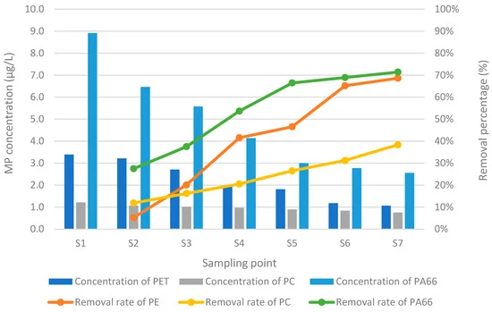
So using stages in sewage treatment is really important for keeping people healthy protecting the natural world and helping cities grow in a way that is good for the environment. Sewage treatment is essential, for maintaining health protecting natural ecosystems and supporting sustainable urban development that is why sewage treatment is so important.
Figure 4: Concentration and removal efficiency of different microplastics (PET, PC, and PA66) at various sampling points during the wastewater treatment process.
Conclusion
In conclusion, we can say that there are four steps in sewage treatment, which are preliminary treatment, primary treatment, secondary treatment and tertiary treatment. Each step plays a significant role to remove pollutants from wastewater. Preliminary treatment helps to remove heavy things that could break equipment. Primary treatment removes floating things and dirt that can cause serious damage to the animal and plants that consume them. Secondary treatment uses living things to eat up harmful elements in the water. Finally tertiary treatment makes the water clean and safe by removing any remaining elements that might negatively impact the animal health.
All these steps together properly wastewater properly before it goes back into rivers, lakes or oceans. Proper sewage treatment helps in reducing pollution which keeps people healthy and thus saves water.
As more people move to cities, having good sewage treatment systems will become more important to keep our environment healthy and ensuring a safe and healthier surrounding for everyone.
Sewage treatment is a key to a healthier environment and sewage treatment helps in making clean water sewage treatment is vital, for our future. As urban populations continue to grow and industrial activities increase, the importance of efficient sewage treatment systems will become even greater in maintaining environmental sustainability and ensuring a healthy future for society.
References
- Tchobanoglous, G., Burton, F. L., & Stensel, H. D. (2003). Wastewater Engineering: Treatment and Reuse. McGraw-Hill Education.
- Metcalf & Eddy. (2014). Wastewater Engineering: Treatment and Resource Recovery (5th ed.). McGraw-Hill Education.
- Spellman, F. R. (2013). Handbook of Water and Wastewater Treatment Plant Operations (3rd ed.). CRC Press.
- Water Environment Federation (WEF). (2018). Wastewater Treatment Fundamentals. Water Environment Federation.
- United States Environmental Protection Agency (EPA). (2023). Wastewater Treatment Process Overview.
https://www.epa.gov/wastewater-treatment
- United Nations Environment Programme (UNEP). (2017). Wastewater: The Untapped Resource. United Nations.
- World Health Organization (WHO). (2018). Guidelines on Sanitation and Health. World Health Organization.
- Figure 1: https://www.researchgate.net/figure/Wastewater-treatment-process-in-industries-This-flow-chart-depicts-the-general_fig1_341051097
- Figure 2: https://www.researchgate.net/figure/Primary-sedimentation-tank-J-Design-of-High-Rate-Trickling-Filter-The-high-rate_fig3_342416504
- Figure 3 https://kenkidryer.com/2020/03/14/about-conventional-activated-sludge/
- Figure 4 https://www.mdpi.com/2073-4441/17/4/574

Question 3. Describe the global and local environmental issues.

Introduction
The world is facing so many problems. The overall population is increasing, industries are expanding, cities are getting larger. We are using up too many natural resources. This is causing issues. These issues are not just bad for the earth, they are also bad for our health. They also negatively affects our economy. They make our lives worse.
We can divide issues into two groups: global environmental issues and local environmental issues. Global environmental issues are problems that affect the whole world. To fix these problems we need people from over the world to work together. Local environmental issues are problems that affect areas or countries. Even though they are local they can still be very bad for the people and animals living in those areas.
It is really important that we understand both global and local environmental issues. If we understand both issues, we can come up with proper plans to fix these problems. By solving this issues we can make the world a better place for everyone. Pollution, climate change and more environmental issues like this need to be solved so we can have a better life and so the earth can stay healthy.
Global Environmental Issues
Global environmental issues are problems that affect the planet. They impact countries at the same time. Examples of environmental issues include climate change, air pollution, deforestation and water pollution. These problems threaten ecosystems, biodiversity and human health. They are a threat to our planet. We need to take action. Global environmental issues are a challenge, for all of us. We face these challenges every day.
Climate Change:
Climate change is a problem for our planet. It is about the Earth’s temperature and weather changing over time. The main reason for climate change is the increase of things like carbon dioxide, methane and nitrous oxide in the air.
These things are bad for the Earth. People make them when they do things like burn gasoline make things in factories and cut down trees and drive cars. When these things get stuck in the air they keep the heat in. This makes the Earth get hotter. We call this global warming.
Climate change is very serious. When the Earth gets hotter the ice at the poles starts to melt. This makes the sea levels get higher. Places near the ocean and countries that are low to the ground are in big trouble because of climate change.
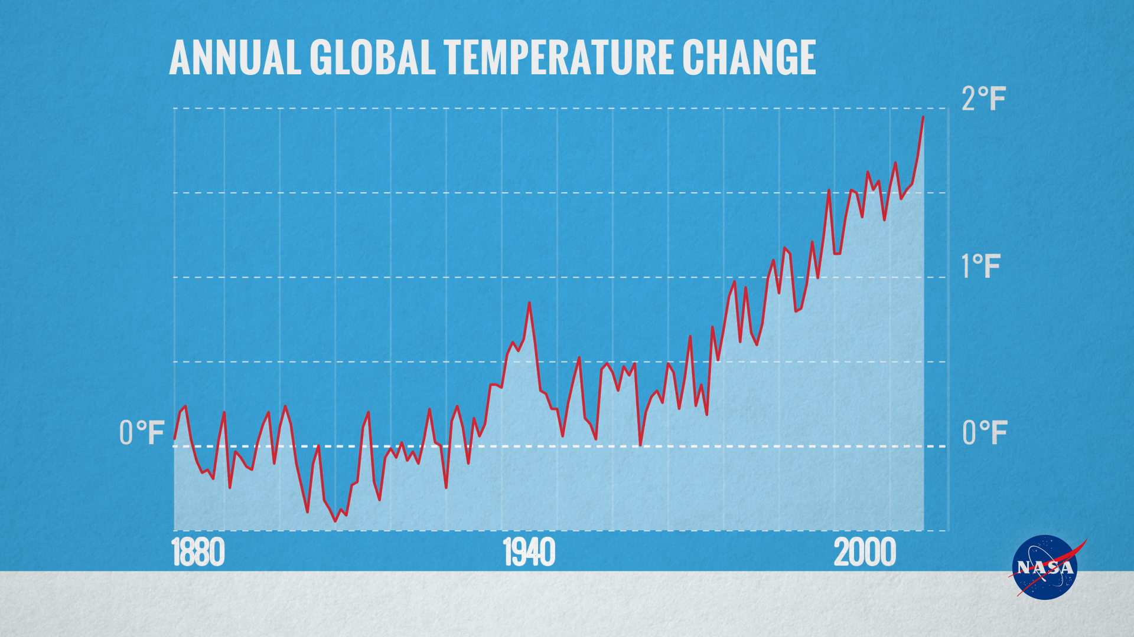
Climate change also makes bad weather happen often like storms, floods, dry spells and heat waves. Climate change can damage plant and crops which can make them harder to grow food and even effects human life negatively. So we need to work to stop climate change make less of these things and find new ways to make energy that do not hurt the planet because climate change is a big problem for our planet.

Figure 1: Global average temperature increase from 1880 to recent years, showing the long-term trend of global warming.

Air Pollution:
Air pollution is a problem for our planet. Many things like gases and dust and smoke and chemicals get into the air we breathe. The main things that cause air pollution are cars and factories and power plants and burning fossil fuels like coal and oil. The air is filled with things like carbon monoxide and sulfur dioxide and nitrogen oxide and particles that we cannot see.
Air pollution is really bad for peoples health. It can damage our lungs and our heart. That is very serious. Air pollution can make people very sick. When people breathe in a lot of air they can get asthma and lung diseases and heart diseases and other serious health problems.
Air pollution also hurts the earth by damaging trees and forests and plants that grow in water. This is a problem for our planet. Air pollution can also cause something called acid rain. This happens when the bad things in the air mix with water vapor. Creating this kind of rain is bad for the earth.
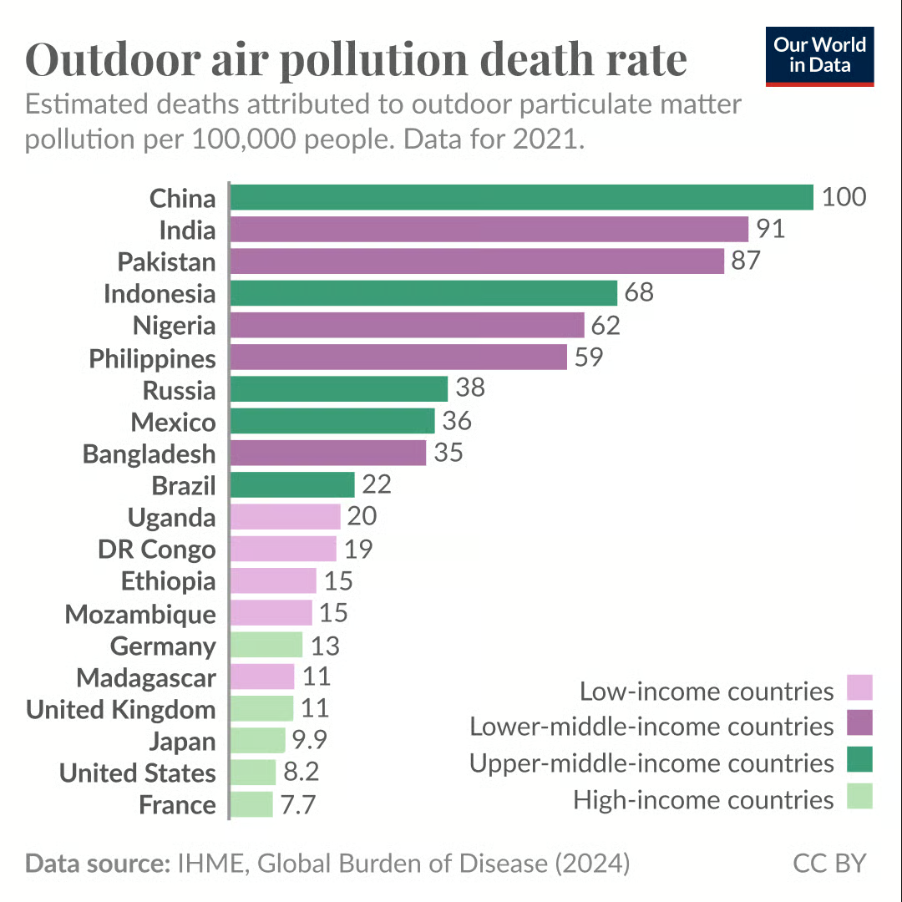
To make the air cleaner we need to use things like wind power. We should use wind power of fossil fuels because it is much better, for the earth. Using wind power will help reduce air pollution and make the earth a healthier place for people and animals to live. We should use wind power and other clean energy to make our planet clean.
Figure 2: Estimated deaths caused by air pollution in different regions of the world.
Deforestation:
Deforestation is when forests are cut down on a scale, for farming, building cities and industries. Forests help keep the earth balanced by taking in carbon dioxide making oxygen and giving homes to animals. Many forests worldwide are being destroyed fast. Trees are chopped down to make space for farms, roads or to get resources.
Deforestation has bad effects. It adds to climate change because there are trees to take in carbon dioxide. It also makes us lose plants and animals because they lose their homes.
Deforestation also makes soil erosion and flooding worse. Without tree roots holding the soil heavy rain can wash it away. Forests are cut down. Trees are cut down. Deforestation. Forests disappear.
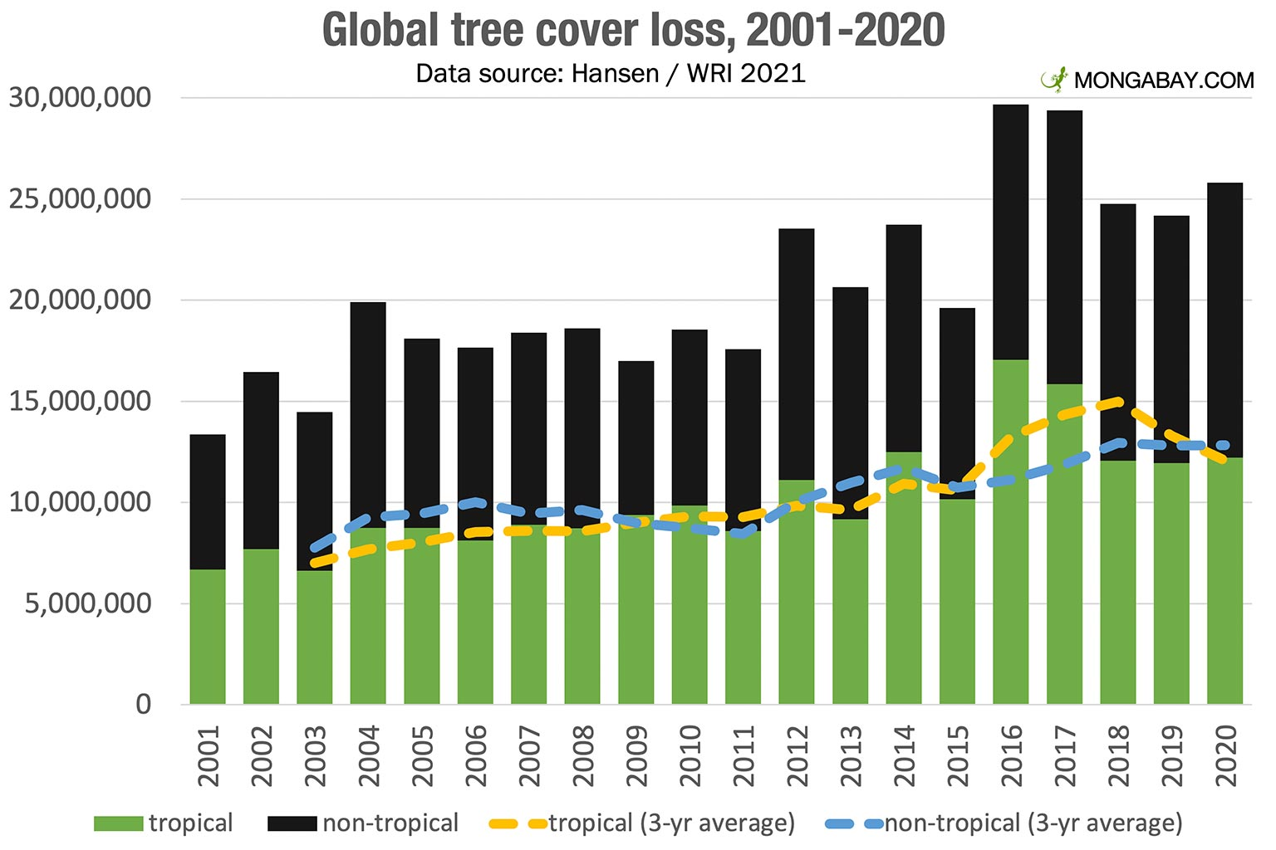
Protecting forests through sustainable land management and conservation programs is essential for maintaining environmental stability.
Figure 3: Global forest area change over time showing the impact of deforestation.
Water Pollution:
Water pollution is an issue that affects our rivers, lakes, oceans and the water under the ground. This happens when bad things like chemicals, waste from factories, sewage and plastic get into our water.
Industries are often guilty of pouring water into the rivers near them. Farms also play a part in polluting our water when they use many fertilizers and pesticides. These bad chemicals can then flow into our rivers and lakes when it rains.
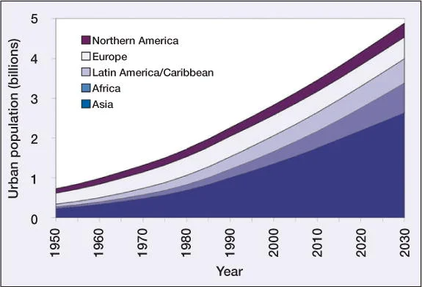
Water pollution is really bad for the animals that live in the water. It can make it hard for them to breathe. It can also poison them. A lot of fish and other creatures die because of the water. When we drink water that's polluted it can make us very sick. We can get diseases, like cholera, dysentery and typhoid fever from water pollution. Water pollution is a problem that affects water pollution and it is something we need to worry about because of water pollution.
Local Environmental Issues
Local environmental issues vary depending on the region and its economic activities, population density, and natural resources. Many developing countries face significant environmental challenges due to rapid urbanization and limited environmental management systems.
Figure 4: Growth of global urban population, which increases environmental pressure in cities
Urban Waste Management Problems:
Waste management is a problem in our community. The city is getting more crowded. That means we have a lot of trash. In some places they do not have a system to pick up the garbage. So the waste just stays on the streets in parks and in our water. When we do not throw away trash properly it causes a lot of issues. Waste management can make bad smells and it can bring in pests like rats and bugs. Waste management can also make the soil and water dirty.
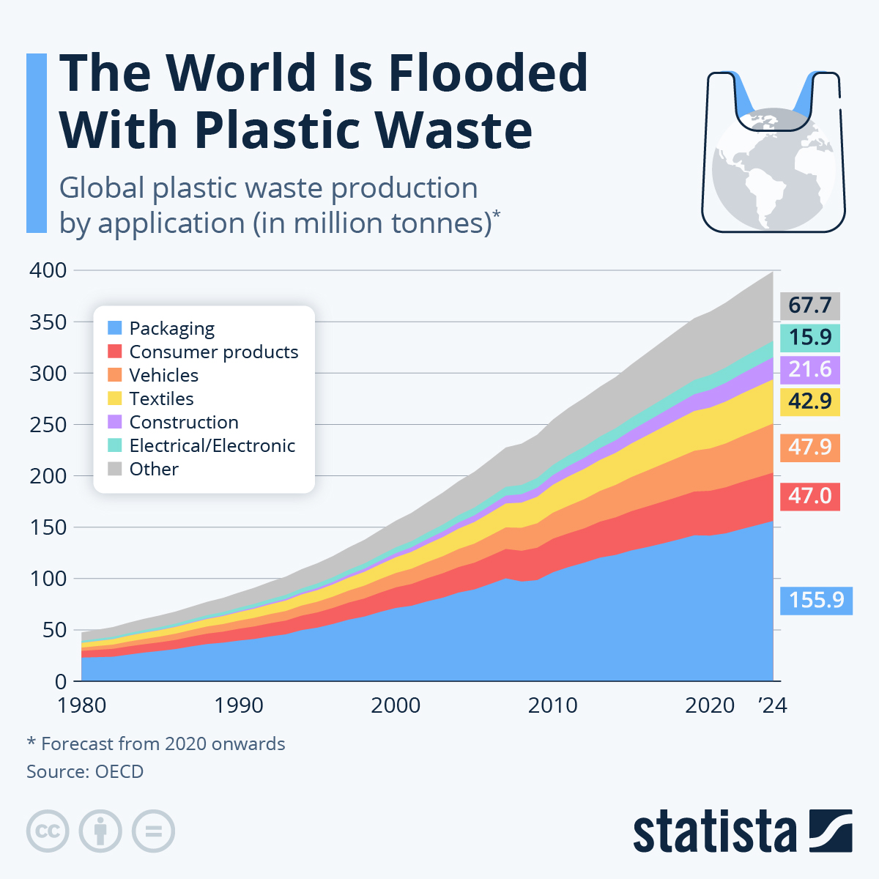
Plastic waste is especially bad because it takes a time to break down. If we have a lot of waste it can block the drains and cause flooding, in the city. We need to have waste management systems programs to recycle and people need to know about the problem so we can fix waste management.
Figure 5: Global plastic waste generation and its contribution to environmental pollution.
Air Pollution in Urban Areas:
Air pollution is a problem in many cities. Many cities have air because of factories and more cars on the road. When there is a lot of traffic people burn gasoline and factories release bad stuff into the air. Construction and dusty roads also make the air dirty.
Bad air in cities can make it hard to see. It creates a kind of fog. This can make people sick, kids and older people and give them breathing problems.
We can make the air cleaner by making public transportation We should also use energy and make factories follow stricter rules, about what they can release into the air. This way we can reduce air pollution in cities.
Water Pollution in Local Rivers:
Many local rivers and lakes have a lot of stuff in them because of the yucky things that come from factories sewage that has not been cleaned and waste from homes. In cities where a lot of people live the dirty water from homes and factories is often put into rivers and lakes without being cleaned first.

For example rivers, near cities get a lot of bad chemicals from factories and waste from homes. This makes the water very dirty. It hurts the animals that live in the rivers.
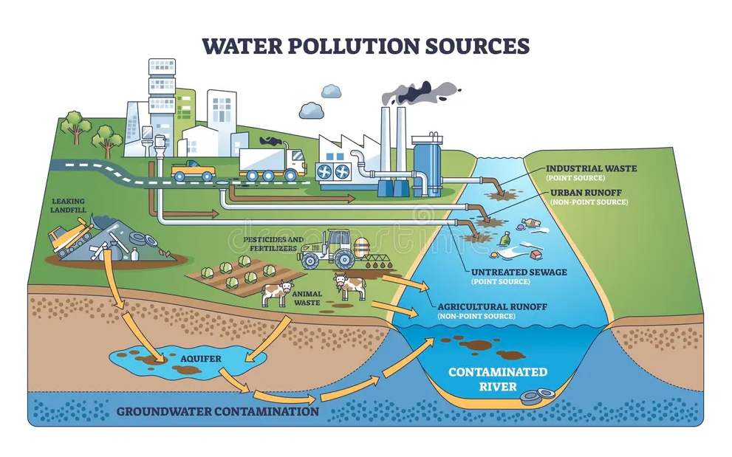
Local rivers that are polluted can also hurt people who live near them and use the water from these rivers to drink, fish and grow food because local rivers are an important part of their daily lives and local rivers are what they rely on.
Figure 6: Major sources of global water pollution including industrial discharge, agricultural runoff, urban runoff, and plastic waste.
Loss of Green Spaces:
The environment in our area has a big problem. This problem is that we are losing spaces in cities. When cities get bigger they often destroy forests and wetlands and farms to build homes and stores. This is bad because green spaces are important, for animals and plants to live.
It also makes cities hotter. Trees and plants help clean the air and make the weather nicer. If we do not have green spaces cities can get very hot. This is called the urban heat island effect. We need to plan our cities. We should have parks and green areas. Plant more trees. This will help keep our cities healthy and nice to live in.
Relationship Between Global and Local Environmental Issues:
Global and local environmental problems are connected. Local issues can add to problems and global changes can affect local communities.
For instance when forests are cut down in one area it can add to climate change worldwide. On the hand climate change can make floods, droughts and extreme weather more likely in local areas.
So fixing problems needs help from both local and global levels. Governments, industries and individuals all need to do their part to protect the environment.
Conclusion
In conclusion, environmental issues are divided into two types: global problems and local problems. Both have effects on nature and peoples lives. Global environmental issues like climate change, air pollution, deforestation and water pollution affect the planet. These problems need countries to work together to solve them. At the time local environmental issues like bad waste management, dirty rivers, polluted air in cities and fewer green spaces directly affect how well people live in their communities.
To solve these problems we need to use sustainable development methods. We also need environmental policies and more people to know about environmental issues. Governments must make rules to protect the environment. Industries must use technologies. People must use resources in a way.When we all work together can we protect our environment. This way we can ensure an more sustainable future, for our children and grandchildren.

References
- IPCC. (2021). Climate Change 2021: The Physical Science Basis. Intergovernmental Panel on Climate Change.
https://www.ipcc.ch
- United Nations Environment Programme (UNEP). (2022). Global Environment Outlook 6. United Nations.
https://www.unep.org
- National Geographic Society. (2023). Environmental Issues and Sustainable Development.
https://www.nationalgeographic.org
- NASA Earth Observatory. (2022). Global Climate Change and Environmental Impacts.
https://earthobservatory.nasa.gov
- World Bank. (2020). Urban Development and Environmental Challenges. World Bank Publications.
https://www.worldbank.org
- International Union for Conservation of Nature (IUCN). (2021). Deforestation and Biodiversity Loss.
https://www.iucn.org
- Food and Agriculture Organization (FAO). (2022). Global Forest Resources Assessment. FAO.
https://www.fao.org
- World Health Organization (WHO). (2022). Air Pollution and Health.
https://www.who.int
- Figure 1: https://svs.gsfc.nasa.gov/12133/
- Figure 2: https://ourworldindata.org/cdn-cgi/imagedelivery/qLq-8BTgXU8yG0N6HnOy8g/75ca1b48-6584-4c7d-4dd9-5c9c8f28a300/w=1080
- Figure 3: https://news.mongabay.com/2021/03/global-forest-loss-increases-in-2020-but-pandemics-impact-unclear/
- Figure 4: https://www.researchgate.net/figure/Global-urban-population-from-1950-to-2030-by-region-Total-urban-population-is-expected_fig1_240777812
- Figure 5: https://www.statista.com/chart/32385/global-plastic-waste-production-by-application/?srsltid=AfmBOoqz7Ori3c-Jw9wOkTVsIaPfcrIWd7MKt9hVgqaNJpmIsxi2DAUf
- Figure 6: https://www.dreamstime.com/water-pollution-sources-visualized-factory-pipes-farm-runoff-sewage-water-pollution-sources-visualized-factory-pipes-farm-image421691745

